**Document Approval**

|  |  |  |  |
| --- | --- | --- | --- |
| **Title/Department** | **Name** | **Signature** | **Date** |
| Author | Paul van Ostenberg |  | 10-02-2021 |
| Reviewer | Theresia Mbithe Mumo |  | 01-03-2024 |
| Approver | Annedien Plantenga |  | 01-03-2024 |

**Document History**

|  |  |  |
| --- | --- | --- |
| **Version** | **Date** | **Summary of the changes** |
| 1.0 | 13-02-2014 | Author first version Christine Deurman. |
| 1.1 | 02-05-2014 | Incorporated comments GvS and GL (COHSASA) |
| 1.2 | 24-06-2014 | Small change in process flow in chapter 5.3 |
| 2.0 | 30-09-2016 | Review of the complete process. Author Daisy van der Putten |
| 3.0 | 27-05-2019 | Review after introduction of SC Rating Tool. Author Annedien Plantenga |
| 4.0 | 08-02-2021 | Incorporated Appeal and Withdrawal Processes |
| 4.0 | 10-02-2021 | Incorporated non-compliance follow-up process |
| 4.1 | 10-08-2021 | Incorporated one paragraph on monitoring and evaluation audits |
| 4.2 | 15-06-2023 | Reviewed, no changes apart from updated logo |
| 4.3 | 01-03-2024 | Replaced iProvide with QES Onboarding Form and Quick scan with Facility by Numbers Form.  Replaced AfriDB with Quality Evaluation Systems (QES), including the related screenshots. |

# Policy

SafeCare Certification represents the independent, unbiased evaluation of the achievement of quality standards in healthcare organizations and is based on standardized, transparent procedures for determining the level of achievement and type of recognition. Level of achievement (1 to 5) is measured against the SafeCare Certification Standards and processes.

# Scope and application

This procedure document describes the steps to be followed in preparation of certification, the actual certification procedures, the reporting of results of a certification assessment, and any follow-up process. The procedures also include the management of the appeal process, and the process for withdrawal and possible re-entry when certification is withdrawn by SafeCare or the organization withdraws from the program.

This document applies to the SafeCare department in Amsterdam, the members of the SafeCare Certification Committee in the SafeCare offices in-country and the Program Director of SafeCare Amsterdam (see QA-CER-002_Composition of SafeCare Certification Committee for names).

# Responsibilities

See QA-CER-003_Certification procedures depending on the level of SC certificate for the responsibilities in the Certification Process.

# Related documents

* QA-CER-002_Composition of SafeCare Certification Committee
* QA-CER-003_Certification procedures depending on the level of SC certificate
* QA-CER-004_Letter expired certificates
* QA-SCS-006_SafeCare Certification Level Algorithm_v7
* SafeCare Certification Assessment Report
* SafeCare Certification Certificate
* QES Onboarding Form and Facility by Numbers Form
* SafeCare Certification Committee Signature list

# Procedure or Process

## Purpose

The SafeCare Certification procedure aims to recognize the facility with a certificate based on the outcome of a SafeCare certification assessment. The certificate will motivate staff through:

* Assuring quick feedback to the teams in country and subsequently to the facilities
* Providing a fair “judgement” of level of achievement
* Providing transparency
* Preventing fraud

The procedure is set up in such a way that it:

* Facilitates an efficient process
* Minimizes mistakes such as: award a high-level certificate to a facility that does not performs well or award a low-level certificate to a facility that performs very well.

## The basis of the certification decision: the certification algorithm.

The certification algorithm has been designed to provide insight into the level of quality based on the overall calculated score and by taking the high-risk deficiencies (critical criteria) into account. The algorithm is designed to correctly identify levels of achievement, reduction in risk and improvement in quality and capture them in the 5 levels as they are currently defined.

Although the algorithm is leading the process, the certification committee has the authority to override the calculated level according to the algorithm and award a different certification level if deemed appropriate.

## Process of certification

The certification algorithm is the basis for the certificate level the facility gets awarded. When the assessment is approved, the certificate level is calculated according to the ‘active’ algorithm. The “Certificates to be approved” appear in a table in the Quality Evaluation Systems (QES) under the section Awards.

The process of certification, including the level of scrutiny, depends on the level of the certificate to be awarded. Level 5 certificates need more people involved in taking the decision, and more in-depth analysis of the scoring data will take place. Therefore, a split in which process to follow is listed below:

|  |  |
| --- | --- |
| SafeCare Level 1, 2, 3 and 4* | Calculated level by the system, will be the awarded level by the Certification Committee (members head quarter (HQ)). Weekly, SafeCare certificate level 1, 2, 3 and 4 candidates will be grouped on a list (Registration of Decision Sheet) to get signed by the Certification Committee (HQ). After at least 2 signatures, the certificate is ready to be awarded. |
| SafeCare Level 5 | SafeCare level 5 certificates, calculated by the system, will always be subject to approval by the majority of the SafeCare Certification Committee (SCC) members. The SCC members will receive an email providing information on the new candidate for a SC level 5 certificate. This information consists of:   * The latest Assessment Report for the facility * Historical data (if available) of previous assessments and QIPs   The SCC members will get 1 week to object the awarding of the SC level 5 certificate. If no objections are received after one week, the certificate will be awarded to the facility.  In case a majority of the SCC members object to the award of the SC level 5 certificate, the case will be discussed during a TC. TC needs to be planned within 1-week time in order to avoid a lengthy timeline. Outcomes of the TC will be put in minutes and acted upon. |

*In case a SafeCare level 1, 2, 3 or 4 certificate needs to be discussed, it will be highlighted in the decision sheet. The SafeCare Certification Amsterdam Committee members will then discuss these.

## Award SafeCare certificates

After the decision to award a certificate has been made, it is approved in the ‘Certificates to be approved’ table. As soon as the certificate has been approved, the following will take place:

* It will be removed from the ‘Awards’ table and appear in QES in the Assessments part under the facility linked to the related assessment:

* In case there was still another valid certificate for the facility, it would be automatically deactivated.
* The responsible Team Leader can download the certificate in QES (both in A4 and A3 format).
* The (by the SafeCare Director) signed certificate can then be printed in the desired format and shared with the facility.

Each certificate has a unique serial number to prevent fraud and is valid for 2 years.

The soft copies of the ‘Registration of Decision Sheets’ will be filed by SafeCare Support in Amsterdam. The SafeCare Support office in Amsterdam is responsible for archiving the signed documents.

## Follow-up to nonconformities following certification assessments

Organizations certified at any level are issued a Quality Improvement Plan (QIP) with their Certification assessment report. The QIP identifies all nonconformities from the assessment and is a tool for the organization to use in understanding, tracking, and resolving the nonconformities, and thus continue to improve and move toward the next level of Certification.

As a continuous quality improvement program, the SafeCare Certification process does not require that organizations take action on the nonconformities. Organization can choose to work towards the next level of Certification or choose to remain at their current level of certification. Thus, the SafeCare Certification program does not require that the organization report progress on the resolution of nonconformities. Organizations can improve at their own pace. However, when an organization seeks further assessments in an effort to move to the next level of certification, all previous nonconformities are reviewed during that assessment.

For organizations that have monitoring and evaluation audits as part of the certification program, the audits are on-site and are not necessarily full system audits. There is follow up of actions taken on nonconformities and the progress is uploaded by the assessor in QES system under QIP progress as highlighted below. A narrative (overview) is written that clearly captures the objectives of the visit.

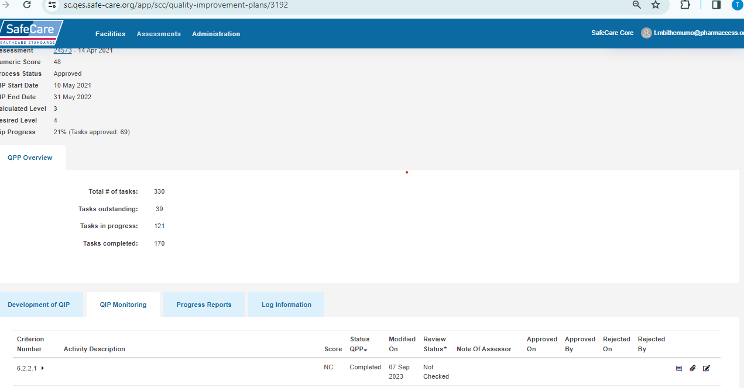

## 5.6. Quality control

The certification activities are described in this document and the chair of the Certification Committee ensures that all activities take place according to what is described in this document. In addition, the chair will use assessment data to regularly (at least quarterly) analyze how the algorithm works (which criteria score best, which criteria score worst etc.). These analyses are used to fine tune the algorithm and/or the risk category allocation of criteria.

# Change in certification status of organizations

## Expired certificates

The country offices will be able to monitor the certificates that are about to expire in the next month on the SafeCare Admin Power BI dashboard. They can thus manage whether facilities need to be approached for a follow-up assessment. On the day of expiry, the certificates will automatically be deactivated in QES.

## Organization withdraws from the Certification program

The country offices will receive automatic mail by the QES Mailer announcing the organizations that have withdrawn from the Certification program. They can thus manage whether facilities need to be approached to verify the decision and to understand the reasons behind the withdrawal. On the day the country office verifies the organization’s withdrawal, the certificates will automatically be deactivated in QES.

Organizations that voluntarily withdraw from the Certification program may re-enter the program within six (6) months at the same level of achievement at the time of withdrawal. If the organization seeks to re-enter the Certification program after six (6) months, they will be considered a new applicant to the program.

## SafeCare withdraws the certificate

SafeCare can withdraw the certificate from an organization for any one or more of the following reasons:

1. The organization has lost its license
2. The organization is engaged in litigation regarding the quality or safety of care
3. The organization has closed buildings for fire safety reasons or public health reasons
4. The organization’s leader or leadership has resigned for reasons of ethical lapses, fraud, or gross mismanagement; or
5. Other reasons as determined by the leadership of SafeCare.

Organizations for which SafeCare has withdrawn the certificate cannot re-enter the program for eighteen (18) months. The organization will be considered a new applicant to the program.

# Appeals

Appeals can be of three types:

1. the organization does not accept the assessment findings, or
2. the organization does not accept the final Certification decision,
3. the organization contests the withdrawal of certification from the organization.

## The organization challenges the assessment findings

When an organization notifies the country SafeCare office and/or the assessment team leader that they do not agree with any portion of the assessment findings - prior to the Certification decision - the report will be held during an investigative period (see 7.2 when the organization notifies SafeCare **AFTER** the certification decision). Reasons for challenging the findings may include for example, a required document could not be located during the assessment, or a required individual to interview was not available at the time of the assessment, or the assessment team misunderstood the evidence provided at the time of the assessment.

The country SafeCare office:

1. Notifies the SafeCare Amsterdam office of the situation and the need to delay any certification decision
2. Communicates with the organization to understand the issue(s)
3. Requests from the organization documentation of their position related to the issues
4. Communicates the issue(s) and documentation to the assessment team leader for clarification and discussion of the issue(s)
5. The country SafeCare Director, in consultation with the assessment team leader, will make the decision to accept or not accept the organization’s position
6. The country SafeCare Director will notify the organization of the decision and will notify the SafeCare Amsterdam office of the decision; and
7. The report will then proceed through the certification decision process.

The SafeCare county office maintains a log of such incidents to support any relevant re-training or quality improvement efforts.

## The organization challenges the Certification decision

When an organization notifies the country SafeCare Director or the Amsterdam SafeCare office that they wish to challenge the Certification decision, it is considered an appeal. The organization must notify SafeCare in writing within ten (10) days that they intend to appeal the Certification decision. Notification of intent to appeal after ten (10) days will not be accepted unless the SafeCare Certification Committee decides to accept the appeal. The organization is then notified they have thirty (30) days to provide information and documents in support of their appeal. The SafeCare Certification Committee manages the appeal process under the direction of the SafeCare Program Manager.

The SafeCare Program Manager will appoint three individuals to an Appeal Panel. The Appeal Panel will hear the appeal and make a recommendation to the SafeCare Certification Committee to accept or reject the appeal. The members of the Appeal Panel are impartial and were not part of the original assessment of the organization or the certification decision being appealed.

* The organization submitting the appeal is notified of the process and informed they have thirty (30) days to submit supporting information and documents. The organization has the right to appear before the Appeal Panel to make their case.
* Evidence in support of the appeal submitted by the organization is evaluated by the SafeCare Certification Committee and a summary report is submitted to the Appeal Panel for their review.
* The Appeal Panel makes a recommendation to the SafeCare Certification Committee to accept or reject the appeal.
* All documents related to the Appeal, and the Appeal Panel and SafeCare Certification Committee minutes and actions are considered confidential.
* The organization submitting the appeal is notified of the final decision.
* All decisions of the Appeal Panel and SafeCare Certification Committee are considered final.
* The SafeCare Certification Committee makes an annual report to SafeCare Senior Management on the nature of appeals and the resolution of appeals.

## The organization appeals the decision to withdraw Certification

When an organization notifies the country SafeCare director or the Amsterdam SafeCare office that they wish to challenge the decision to withdraw the organization’s certification, it is considered an appeal. The organization must notify SafeCare in writing within ten (10) days of notification to the organization of the withdrawal of certification that they intend to appeal the decision. Notification of intent to appeal after ten (10) days will not be accepted unless the SafeCare Certification Committee decides to accept the appeal. The organization is then notified they have thirty (30) days to provide information and documents to support their appeal. The SafeCare Certification Committee manages the appeal process under the direction of the SafeCare Program Manager. The appeal proceeds through the process describe in 7.2.